| **Project Report**    Since 1962  **Volunteering at Child Vision Foundation - NGO**  Submitted by  Mayur Pimpude  Group No: 3  Submitted to  Dr. Geeta Ajit  (in partial fulfillment of the requirements of the PCE-2 course 2022-2023)  Vivekanand Education Society’s Institute of Technology  Chembur, Mumbai – 400 074  September 2022 |
| --- |

**Declaration**

I am Mayur Pimpude student of Semester V, third year Engineering from Department of AI & DS , V. E. S. Institute of Technology, hereby declare that the project entitled Volunteering at Child Vision Foundation - NGO , submitted to the University of Mumbai for the academic year 2021-2022, is a record of an original work done by me under the guidance of Dr. Geeta Ajit, Assistant Professor, Department of Humanities and Applied Sciences, V.E.S. Institute of Technology, Mumbai -400074.

This project report is submitted as a partial fulfillment of the requirement of the subject Professional Communication and Ethics -2 in Semester V.

Date: 22-09-2022 Name : Mayur pimpude

Place: VESIT chembur Signature:

**CERTIFICATE**

This is to certify that the report entitled

**Volunteering at Child Vision Foundation - NGO**

that is being submitted by : Mayur Pimpude

from Class: D11AD, AI & DS Department, V.E.S Institute of Technology

In partial fulfillment for the subject Professional Communication and Ethics -2 to the University of Mumbai is a record of bonafide work carried out by him/her under my guidance and supervision.

Dr. Geeta Ajit

Assistant Professor

Department of Humanities and Applied Sciences

V.E.S. Institute of Technology

Mumbai -74.

**Group No: 3**

| **Sr No.** | **Name of the Group Members** | **Roll No** | **Designation** |
| --- | --- | --- | --- |
| 1 | Saransh Badlani | 3 |  |
| 2 | Satyam Dubey | 13 |  |
| 3 | Sneha Kadambala | 23 |  |
| 4 | Arya Kurup | 33 |  |
| 5 | Mayur Pimpude | 43 |  |
| 6 | Priyanshu Singh | 53 | Leader |
| 7 | Govind Tiwari | 63 | Deputy Leader |

**Acknowledgements**

I would like to express my special thanks to our professor Ms. Geeta Ajit who gave my team the opportunity to do this wonderful project for the NGO, which also helped my team in doing a lot of Research and we came to know about so many new things. I am really thankful to her.

A special gratitude I give to our NGO manager Mr Kumar Abhinav and project manager, Mr Manikandan , whose contribution in stimulating suggestions and encouragement, helped me to coordinate my project.

Furthermore I would also like to acknowledge the thanks to the staff of Child Vision Foundation who have invested his full effort in guiding the team in achieving the goal. I have to appreciate the guidance given by the other supervisors.

**Table of Contents**

1. Abstract
2. Chapter 1: Introduction
3. Chapter 2: Description
4. Chapter 3:( Analysis)
5. Conclusion
6. References and Bibliography
7. PPT of Presentation
8. Project Proposal

**Abstract**

Across Mumbai, government data shows there are 30,388 people with disability, which is 0.24 percent of the population. People with disabilities are also far less likely to be employed than workers with no disabilities (from cnbc). Also not every diabled person has their correct and best instrument that can help and assist them in their disability. Our goal was also to identify various disable people who required help and support. We plan to offer our time and support to these people by helping them through our NGO in their events in which we would distribute equipment and conduct surveys to find needy disabled people and how we can assist them in various ways and aspects.

1

**Chapter 1: Introduction**

1.1 **Overview**:

Our group aims to provide all possible help to underprivileged and disabled people by assisting our NGO in various activities that will be beneficial for them.We would also conduct survey in which we would collect information on disabled and underprivileged people and through this survey we would help our CVF NGO with various ideas and thoughts on how can we help this people for their betterment and can we implement them effectively. The group will be volunteering at the NGO for a minimum of 15 days (30 hours).

1.2 **Background and motivation** :

Across Mumbai, government data shows there are **30,388** people with disability, which is 0.24 percent of the population. People with disabilities are also far less likely to be employed than workers with no disabilities (from cnbc). Also not every diabled person has their correct and best instrument that can help and assist them in their disability. We plan to offer our time and support to these people by helping our NGO in their events in which we would distribute equipment and conduct surveys to find needy disabled people and how we can assist them in various ways and aspects.

About Child Vision Foundation **:**

Child Vision Foundation ( CVF ) is a registered non-political, non-profit secular NGO based in Mumbai working on the issue of Complete Child Care with a team of dedicated and skilled professionals since the year 2013. CVF has reached out to over 10,000 children and adults directly and over 30,000.00 individuals indirectly since its inception.

CVF is currently working from Mumbai in Maharashtra with a child centric model of intervention in the area of Complete Child Care (CCC) with a balanced emphasis on prevention and healing component.

2

1.3 **Objective**:

* To volunteer at the organization for a minimum of 15 days (30 hours).
* To help the Conducting events.
* To help the organization with technical aid.
* To give suggestions or propose ideas to improve the programme.
* To develop communication skills dealing with real life problems

1.4 **Methodology**:

We had a look at the many NGOs working towards betterment of our society and found a CVF NGO which aligned with our goals and we expressed our interest in working with them. They accepted our proposal and organized a visit to their head office in Kurla,swastik chambers. Our work is to manage events conducted by NGO and assist them in all possible ways.

We would also conduct surveys regarding collecting information on needy disabled people and also help NGO to find qualities in these people so that our NGO can help them get jobs and respectable positions in society.

3

**Chapter 2: Description**

**Our Mission:**

Our aim is to assist NGO in organizing their events and to look after management of events and also to assist disabled people during the events. We will also conduct surveys on the ground with NGO in which we will explore who are needy disabled people and how we can upbring these people in our society. And what all support we can provide to them to make their life a bit easy.We would learn qualities required in the real world such as team-work in coordinating tasks amongst ourselves, consistency in working for fifteen days, character development, humbleness and get a different perspective in life.

**Problem Statement :**

Primarily many disabled people are not well supported by their families as the required equipment is expensive and this costs them in their daily living. Also these people have their talent within themself but due to their disability they don't have that confidence in them to showcase them in society.

Looking after this issue our NGO has started a project named “Helping Disables”.

**How will this project solve the problem?**

In this project we will conduct an event in which we would distribute the equipment to the disabled people who are really in need of this equipment. We would also help these people in all other necessary ways. This event is also important as in this event most of the performers will be diabled but will still showcase their talent through this event. This will help others disabled by motivating them and helping them create self confidence within themself.

We will also help our NGO in conducting survey in which we would enlist the needy disabled people and assist them in various ways as per their requirement.And find the talent and qualities in them which can help them to get self reliant and not dependent on society by helping them to secure good jobs.We also help these people in boosting their confidence and motivating them so that they could overcome their fears.

4

**Chapter 3: Analysis**

## Day 1 : Aug 13, 2022

On the first day we were given an introduction about child vision foundation works, mission and vision of this NGO. To understand this we were asked to go through their brochure , pamphlets and visit the website. How this NGO functions also was given an introduction about their team and current project they are working on and how we as a volunteer can make change in this initiative.



Why we are there for ngo and what are the steps and basic understanding before we join ngo this is what our ngo resource manager wanted to see within us.They generated the need and meaning and also asked to have selflessness and a positive attitude towards what we work .

Teamwork is the most important part of our job. I also understood why we need NGO in our society. We helped them pick up ration bags that we will distribute on independence day to the needy people as from here on our true work towards ngo begins.

5

## Day 2 : Aug 15, 2022

The start of Day two was the onset of our first field service at Jai Himgiri Society, Swastik Park, Chembur, which was an epicenter of a widespread slum in that area. Our Day started by collecting ration bags, Eatables, and our National Flag from the head office of our NGO. We Carried our Enthusiasm with great pride walking on the streets with our tricolor flag toward our destination which was about three kilometers away, meanwhile helping the people who need our help in the nearby areas, by providing them with one day's ration.

We reached our destination sharp at 9.00 AM, as the flag hosting event was going to start by 9:30 AM. We were welcomed with a round of applause by all the members in the chawl, this was a very eternal moment for all of us, and it pumped us to work even more than what we had expected before reaching our destination.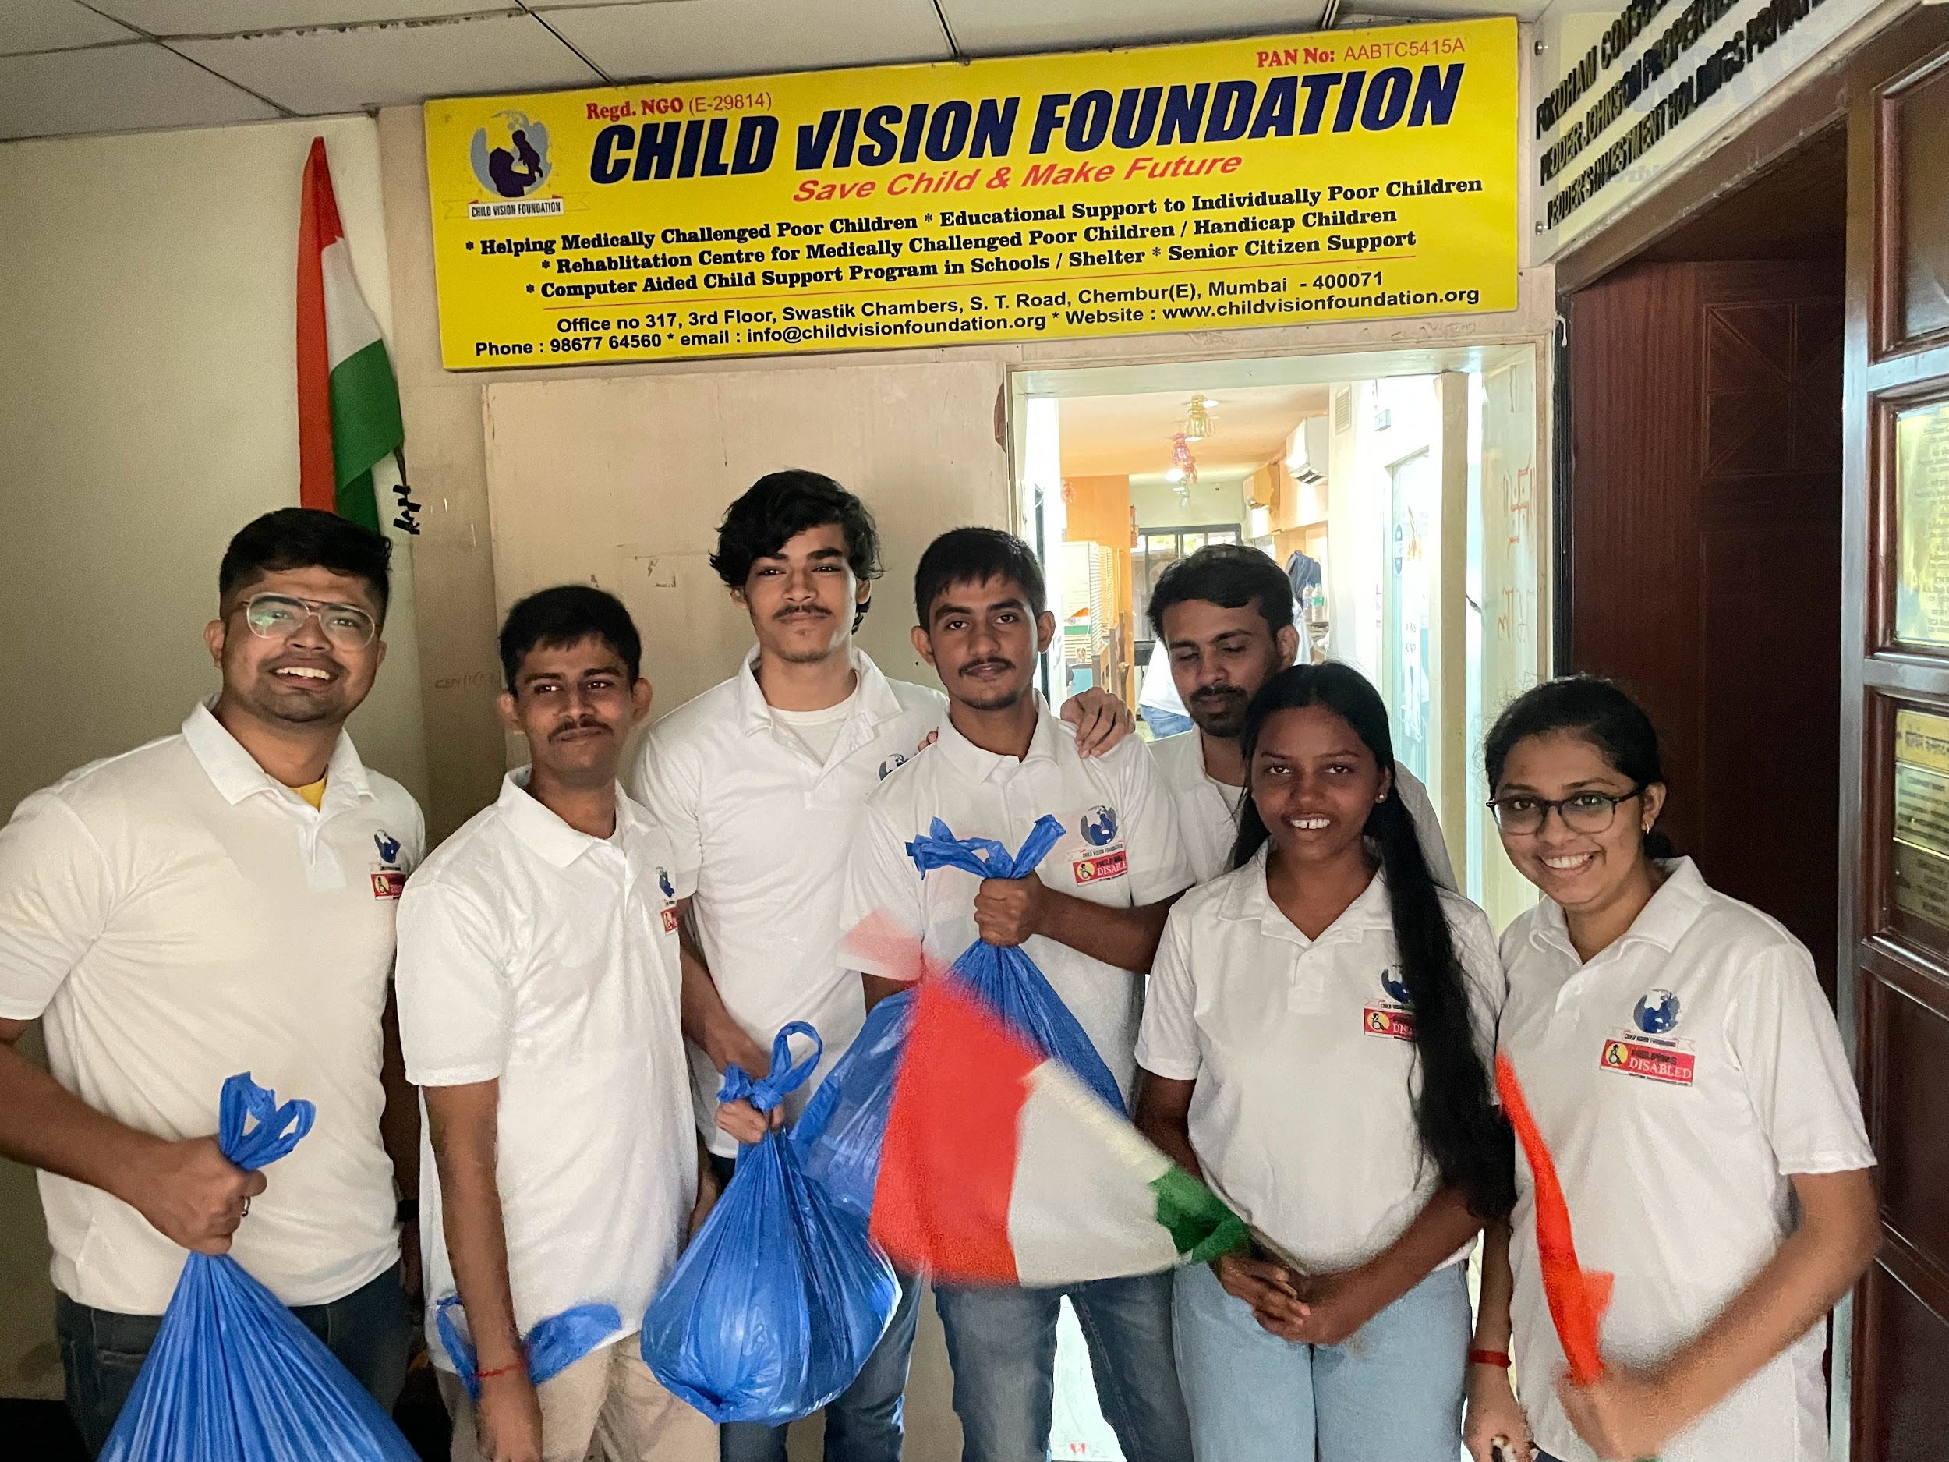

We started putting our banner, placard, and our national flag for the flag hosting event. Meanwhile the guest Mr. Sanjay Pandey arrived, looking at our preparation and our willingness to help, he felicitated our manager Mr. Kumar Abhinav, and us with a bouquet and a shawl.

 6

Since it was the “Azadi ka Amrit Mahotsav” we distributed the tricolor flag to every child in the locality and soon we all stood for the national anthem. After which we started volunteering for the snacks distribution for small children and then the adults in the chawl.

This event was a true eye-opener for us, which not just taught us about how to successfully organize an event but, what are the needs of the people who belong to the category of lower Income Class. This event gave us a lesson that there are people who need our help and we must give back to society some of the learning we have done, more than earning our first lakh and crore which our case might be.

**Day 3 : Aug 18, 2022**

The third day at NGO was a meeting held for planning and preparation for the event “HELPING DISABLED” which was organized on Aug 20th with the vision of Helping differently abled and needy with Equipments and Assistive devices. It was going to be a grand event with an approximate of 200 beneficiaries getting aided. The event was basically a distribution programme of Equipments and Assistive devices which was to be initiated by ‘Deep Prajwalan’ and continued by entertainment program, distribution to the beneficiaries and snacks distribution.

 7

The workflow of the event was discussed along with the venue. The list of people attending the event included Chief Guests, VIP’s, Beneficiaries and their family members, volunteers and the NGO management staff. We were assigned with our responsibilities and tasks as a volunteer with the position and places to be handled and managed at the venue on the day of the event as it was going to be a day long event.

We learnt not only how to plan an event which was going to be held on a large scale but also made us think on how to look at different aspects of the event, what’s the importance of preparation and planning, thinking of all the problems that can occur in the first place and have a proper backup plan for every situation and most importantly getting prepared for the worst and tackle problems on ground reality.

## Day 4 : Aug 21, 2022 10:30 to 7.30 [8 Hrs]

The highly anticipated event of our NGO, 'Helping Disabled,' to aid differently-abled people with assistive equipment like a blind stick, hearing aid, wheelchair, tricycle, and axillary crutches took place on the fourth day.

We reached the venue, Zaverben Popatlal Sabhagraha Auditorium, Ghatkopar, at 11:00 A.M. to foresee the seating arrangement of the guests and the beneficiaries and set the pieces of assistive equipment up for display. Our fellow team members then proceeded to their allocated positions. Few volunteers were put on duty at the Ghatkopar railway station in case the visually impaired or other invitees faced problems locating the venue. The beneficiaries had begun to arrive and were personally led inside the venue by our team and provided tokens. The tokens were distributed on the spot according to the seating arrangement. Volunteers inside the hall directed the beneficiaries to their respective seats according to the token provided. As some of the beneficiaries wished to be seated with their kin, we were able to coordinate through the last moment changes in a hassle-free manner.

8



Our Manager and fellow team members gave the Chief guests a warm welcome.

The inaugural function commenced at 3:00 P.M. with the lighting of the lamp by the chief guests and the other dignitaries, followed by the National Anthem. Beneficiaries were then escorted to the stage and presented their respective equipment by the chief guests. Various performers and the staff of our NGO enthralled the audience with their spectacular dance and singing performances. Mr. Kumar Abhinav (manager of NGO) delivered the vote of thanks. We then distributed snacks and water to everyone in the venue.



Through this event we learnt various aspects of event management and how proper communication and coordination among various teams is crucial for smooth functioning of an event. Most importantly, this event gave us a chance to help our society and has also motivated us to work on societal problems with the simple belief that you can work on something that doesn’t benefit you alone.

**Day 5 :** Aug 23, 2022 **2:00 pm to 5.30 pm**

The Day fifth at the NGO had a meeting about the Event “HELPING DISABLED” feedback and learning.We had discussion on the topics like managing the crowd and handling the event.



We discussed the problems faced during the Event “HELPING DISABLED” for example We had designed a work allotment map of working the volunteers but during the event all the things were not as per the actual planning .we changed the work allotment map by seeing the requirements at different locations at the auditorium.

We also shared the key takeaways from the events like managing the crowd and the importance of teamwork in the event .We had discussed core steps to plan an event and gone through the detailed analysis of managing the event. At the end we had submission of shirts and id cards allotted by the child vision foundation.

## Day 6 : Sep 18, 2022 2:00 pm to 5.30 pm [3:30 Hrs]



On this day we were asked to take survey forms and explained what all details are required to fill this form. We were also briefed about how to approach disable people with form filling and to convince them for this.

We were also divided into 3 groups of equal number as per our area so we could easily coordinate with our team for this activity. Further we were asked to help a minimum of 3 disable people per group .

The survey form was to help NGO find more needy people who require their assistance and that can help their upbringing.

11

**Conclusions :**

We learned many things during our journey of working with CVF NGO. One of them is teamwork, time management, and coordination. During events we also saw that disable people don’t require our sympathy but look at them as equal to us. There are many who have talent in them but have low confidence in them. It's our job to help them believe in themself. There are many underprivileged people who struggled hard and reached their goal even after immense difficulties such as our own NGO resource manager Mr Manikandan sir.

When we put our efforts to help some and see their smile on their face is the most joyful part of that time.

It was our pleasure to work with them and help these people in the true means.

**Recommendation :**

There should not be any time boundation to work in an NGO . It should be an individual's choice for how long he/she is willing to work from his/her heart. Hours don't matter, what matters is our quality of time to understand and help people and society.

12

**Appendices:**

Survey Form :

The form is provided by NGO to use help and conduct a survey to find any underprivileged disable who needs help.

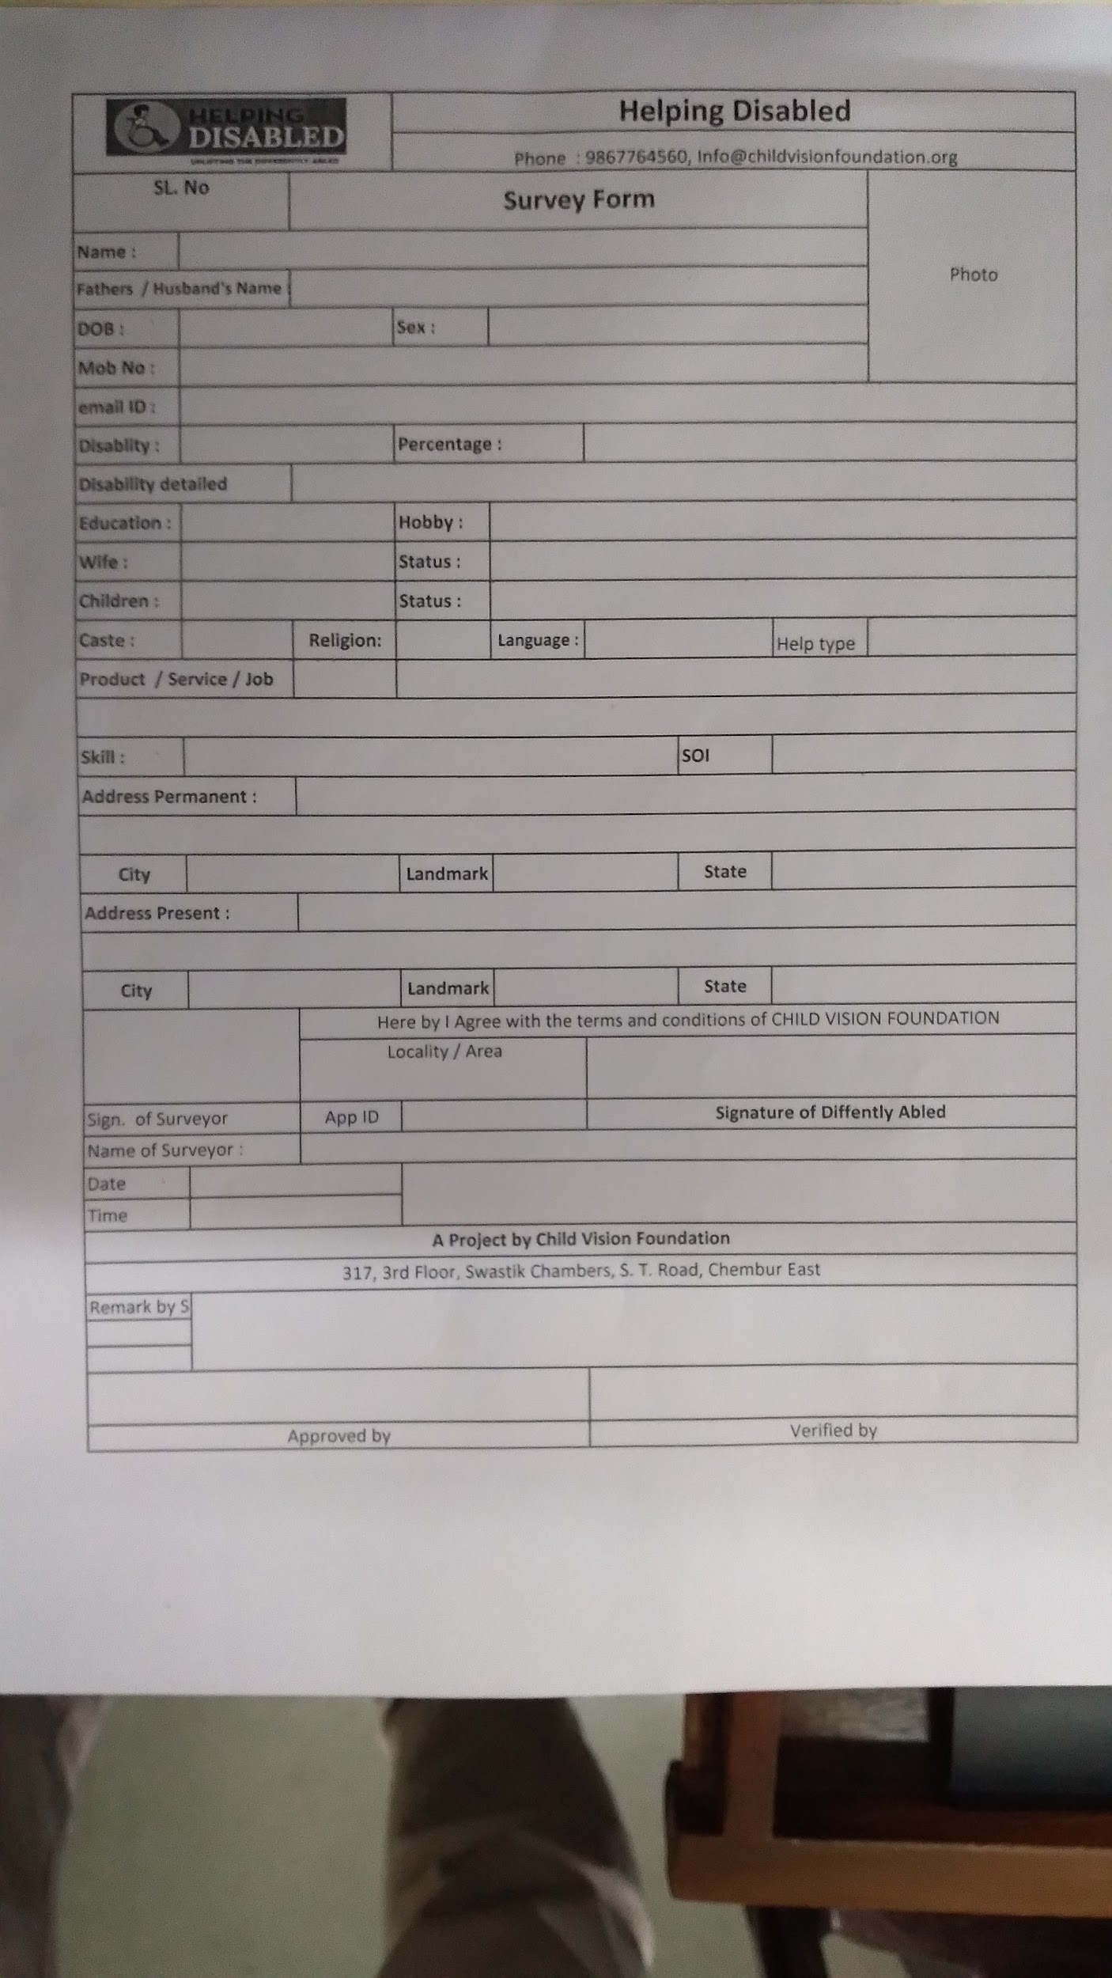

13

**PPT**

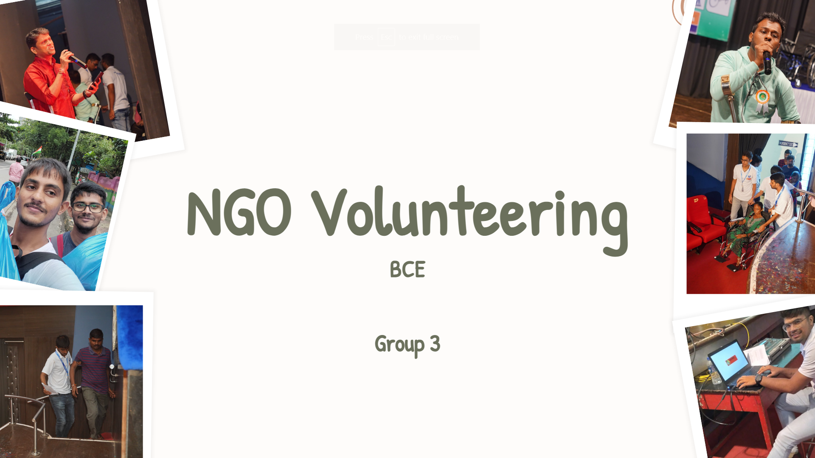

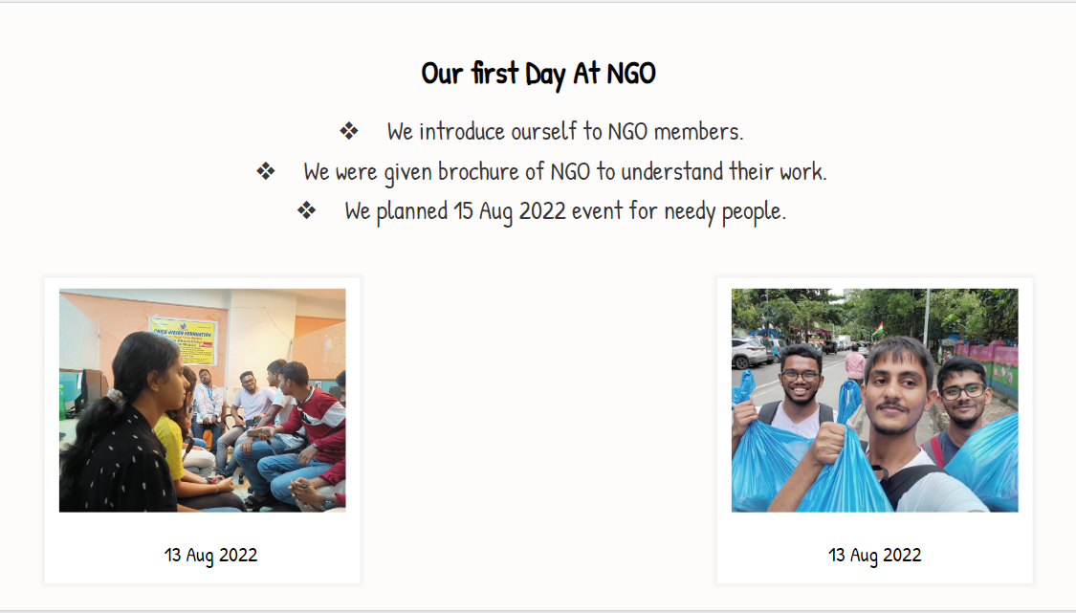

14

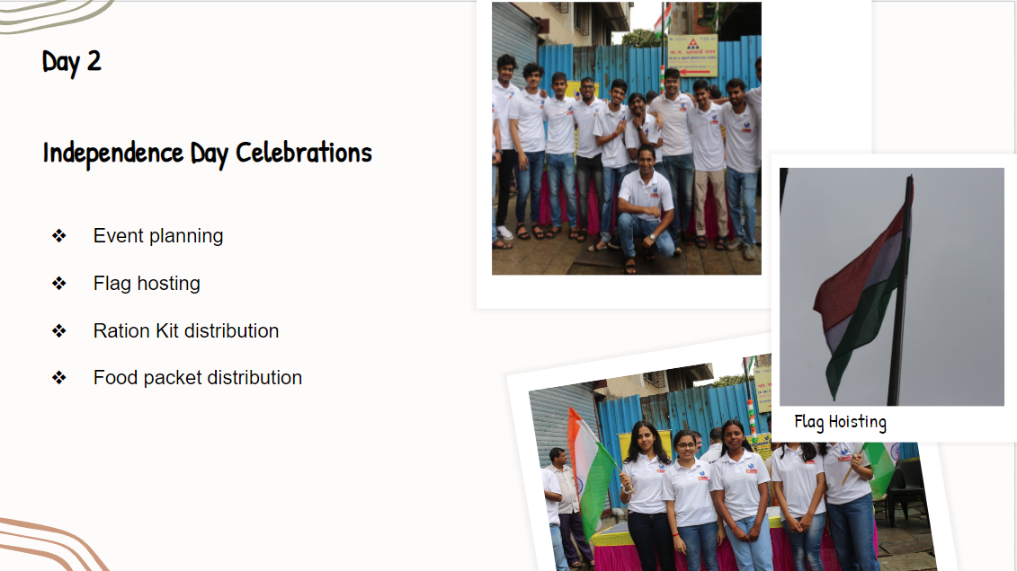

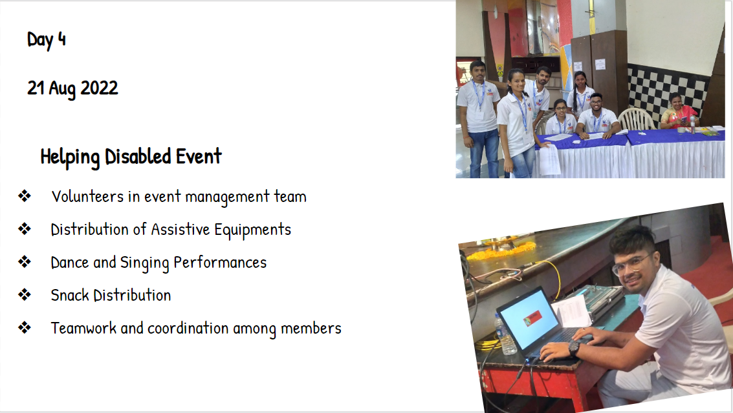

15

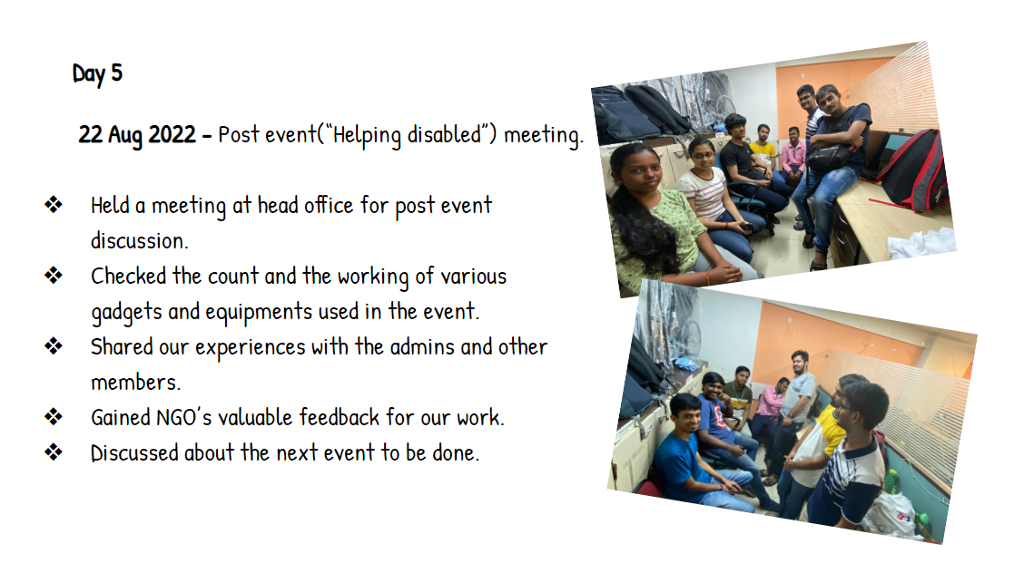

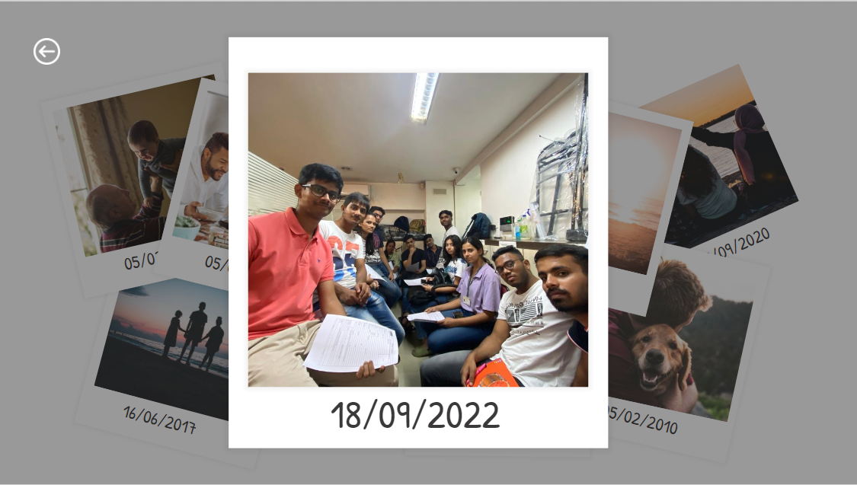

16

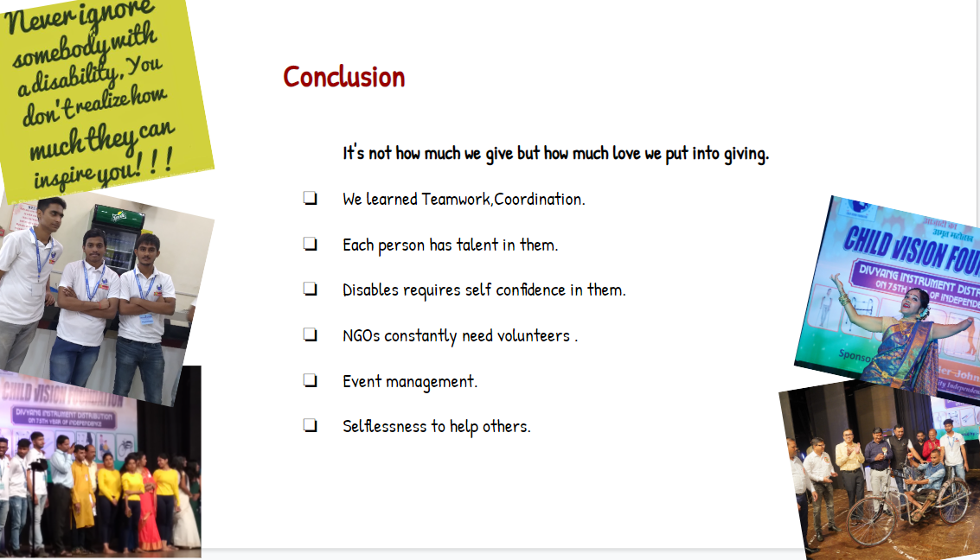

17

**References and Bibliography :**

Website of CVF :**-** [**https://www.childvisionfoundation.org/**](https://www.childvisionfoundation.org/)

Facebook account of CVF **:-** [**https://www.facebook.com/childvisionfoundationngo/**](https://www.facebook.com/childvisionfoundationngo/)

Indianexpress Newspaper :- [**https://indianexpress.com/article/cities/mumbai/mumbai-study-finds-1-3-disabled-people-in-m-east-ward-7081157/#:~:text=Across%20Mumbai%2C%20government%20data%20shows,and%20out%20of%20government%20schemes.**](https://indianexpress.com/article/cities/mumbai/mumbai-study-finds-1-3-disabled-people-in-m-east-ward-7081157/#:~:text=Across%20Mumbai%2C%20government%20data%20shows,and%20out%20of%20government%20schemes.)

**PPT of presentation :**

[**https://docs.google.com/presentation/d/1LsiDBZEoMaJ6b5Wy5BOLCU_Xw0sA55EfcU3uYz77oAE/edit?usp=sharing**](https://docs.google.com/presentation/d/1LsiDBZEoMaJ6b5Wy5BOLCU_Xw0sA55EfcU3uYz77oAE/edit?usp=sharing)

18